**Experiment5**

|  |  |
| --- | --- |
| **Student Name:** Anushka | **UID:**22BET10126 |
| **Branch:** BE -IT | **Section/Group:**22BET/IOT/702/B |
| **Semester:** 6th | **Date of Performance:**21/02/2025 |
| **Subject Name:** Advanced Programming Lab-2 | **Subject Code:** 22ITP-351 |

1. **Aim 1 :**[**Kth Largest Element in an Array**](https://leetcode.com/problems/kth-largest-element-in-an-array/)

Given an integer array nums and an integer k, return *the* kth *largest element in the array*.

Note that it is the kth largest element in the sorted order, not the kth distinct element.Can you solve it without sorting?

### [**Merge Intervals**](https://leetcode.com/problems/merge-intervals/) **:**

Given an array of intervals where intervals[i] = [starti, endi], merge all overlapping intervals, and return an array of the non-overlapping intervals that cover all the intervals in the input.

1. [**Search in Rotated Sorted Array**](https://leetcode.com/problems/search-in-rotated-sorted-array/)**:**

There is an integer array nums sorted in ascending order (with distinct values).

Prior to being passed to your function, nums is possibly rotated at an unknown pivot index k (1 <= k <nums.length) such that the resulting array is [nums[k], nums[k+1], ..., nums[n-1], nums[0], nums[1], ..., nums[k-1]] (0-indexed). For example, [0,1,2,4,5,6,7] might be rotated at pivot index 3 and become [4,5,6,7,0,1,2].

Given the array nums after the possible rotation and an integer target, return *the index of*target*if it is in*nums*, or*-1*if it is not in*nums.

1. [**Search a 2D Matrix II**](https://leetcode.com/problems/search-a-2d-matrix-ii/):

Write an efficient algorithm that searches for a value target in an m x n integer matrix matrix. This matrix has the following properties:

* Integers in each row are sorted in ascending from left to right.
* Integers in each column are sorted in ascending from top to bottom.

1. [**Kth Smallest Element in a Sorted Matrix**](https://leetcode.com/problems/kth-smallest-element-in-a-sorted-matrix/):

Given an n x n matrix where each of the rows and columns is sorted in ascending order, return the kth smallest element in the matrix.Note that it is the kth smallest element in the sorted order, not the kth distinct element.You must find a solution with a memory complexity better than O(n2).

1. [**Median of Two Sorted Arrays**](https://leetcode.com/problems/median-of-two-sorted-arrays/)**:**

Given two sorted arrays nums1 and nums2 of size m and n respectively, return **the median** of the two sorted arrays.The overall run time complexity should be O(log (m+n)).

1. [**Sort Colors**](https://leetcode.com/problems/sort-colors/) :

Given an array nums with n objects colored red, white, or blue, sort them [**in-place**](https://en.wikipedia.org/wiki/In-place_algorithm)so that objects of the same color are adjacent, with the colors in the order red, white, and blue.We will use the integers 0, 1, and 2 to represent the color red, white, and blue, respectively.You must solve thisproblem without using the library's sort function.

1. **Objective:**

* Find the kth largest element efficiently without sorting the entire array.
* Given overlapping intervals, merge them into a minimal set of non-overlapping intervals.
* Find the target element in a rotated sorted array in O(log n) time.
* Search for a target efficiently in a row-wise and column-wise sorted matrix.
* Find the kth smallest element in a sorted matrix efficiently.
* Find the median of two sorted arrays in O(log (m+n)) time.
* Sort an array containing 0s, 1s, and 2s in-place without using built-in sort functions.

1. 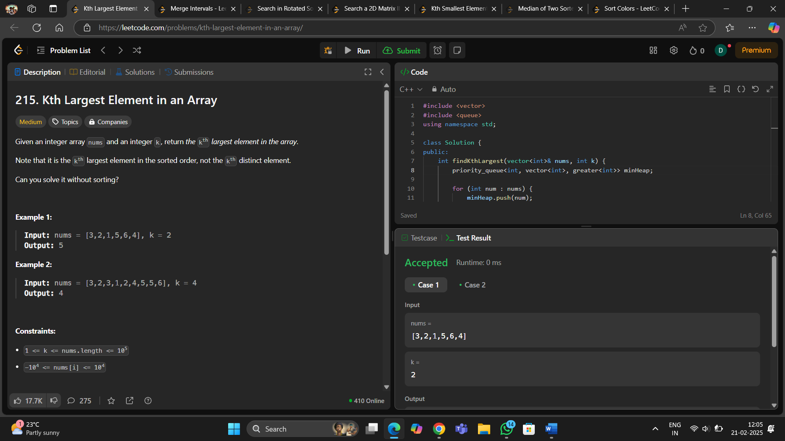**Implementation of Code/Output1 :**
2. 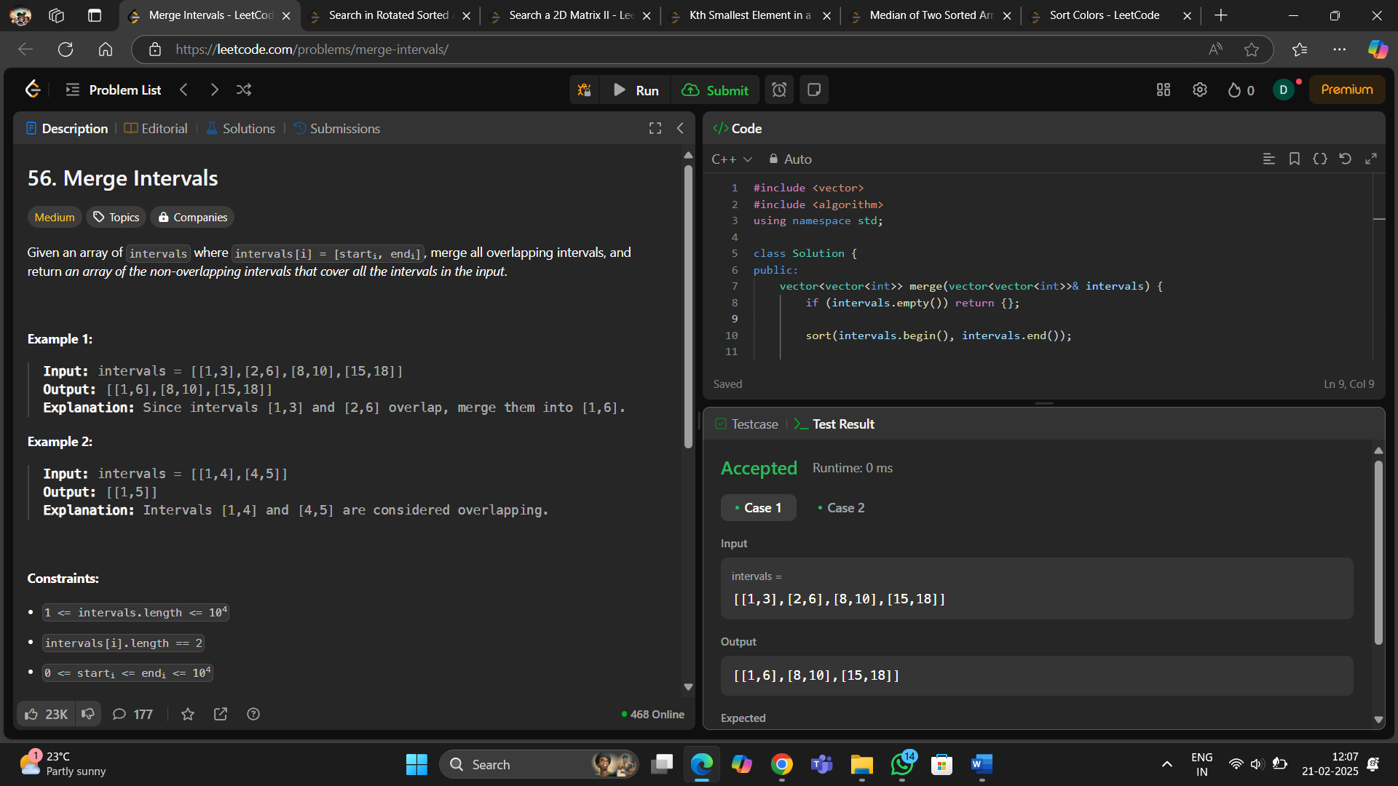**Code2 :**
3. 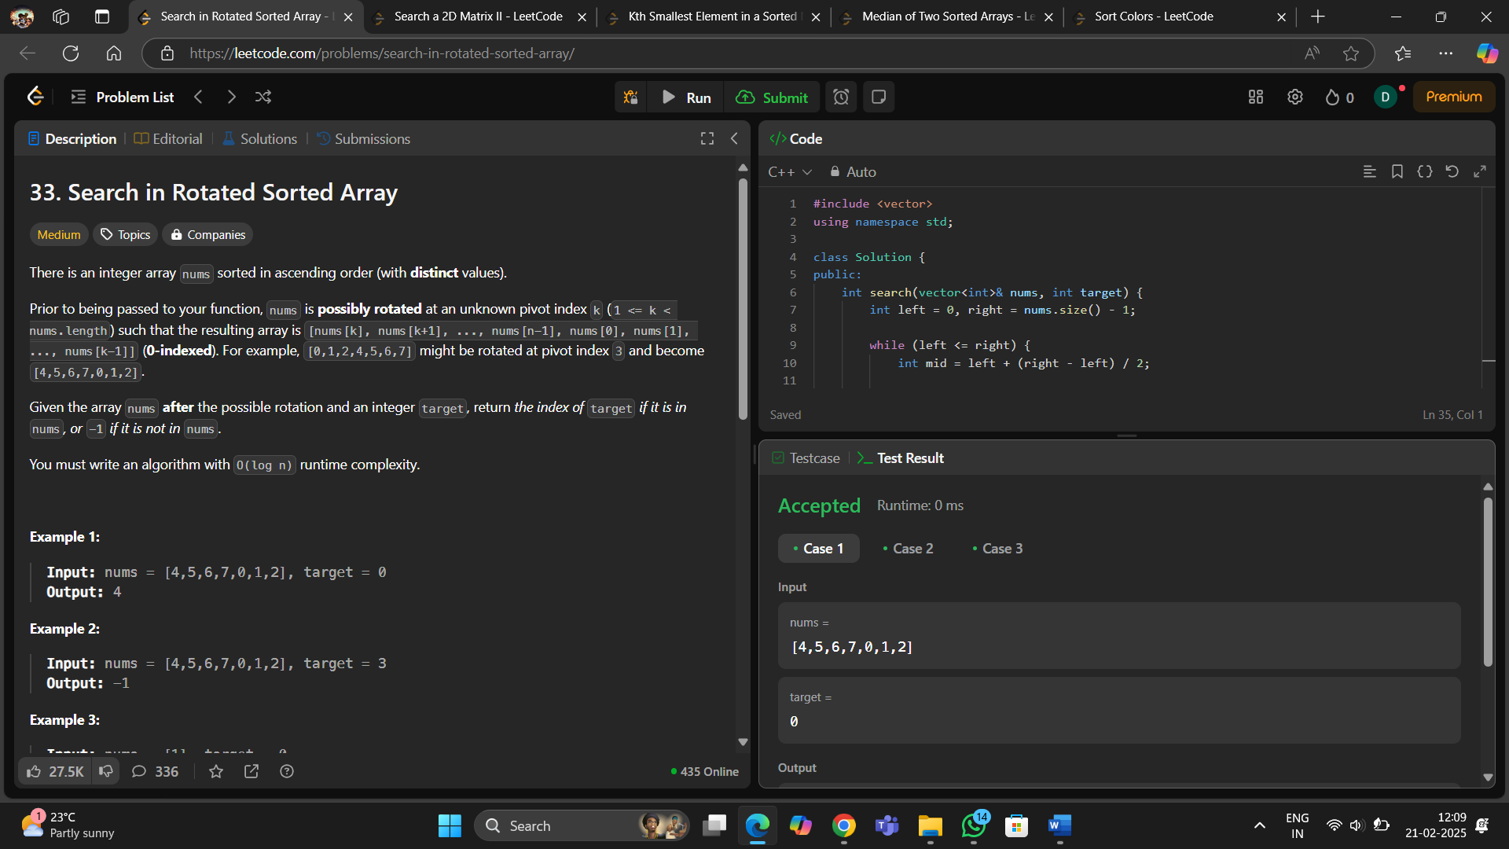**Code 3 :**
4. 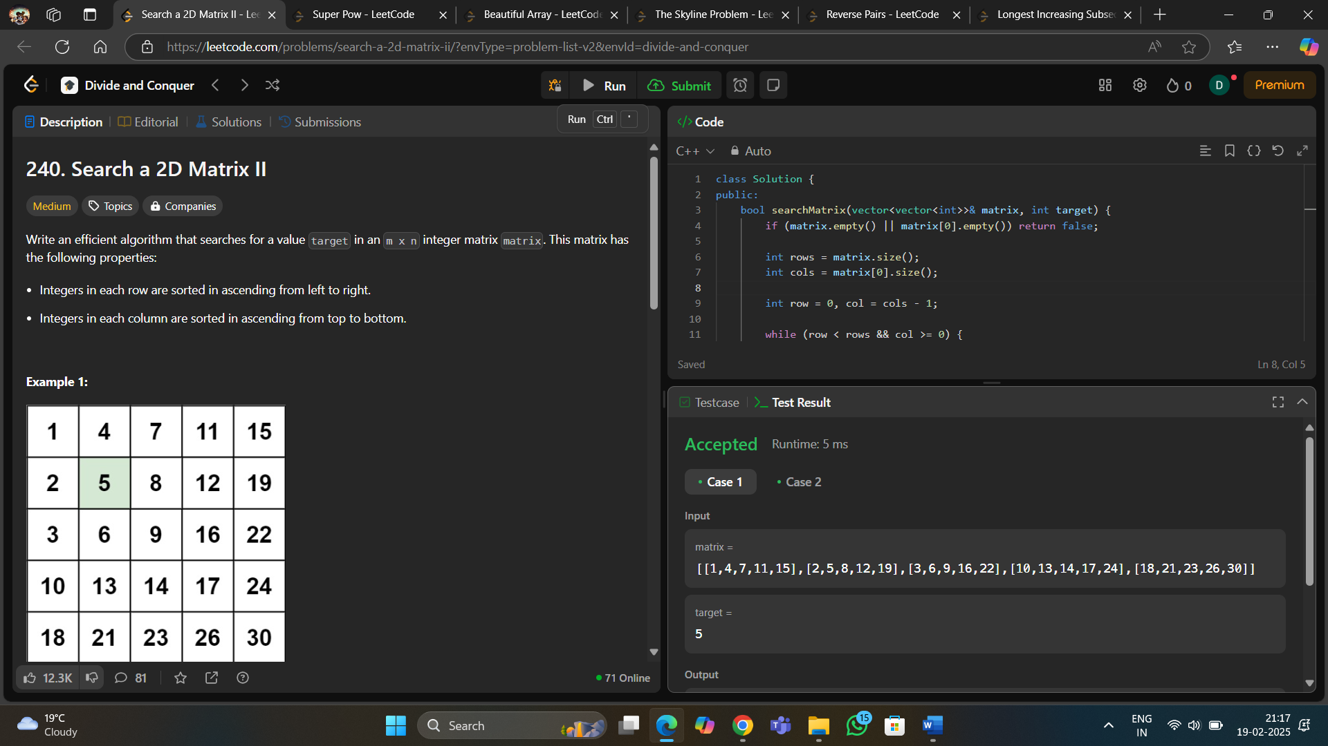**Code4 :**
5. 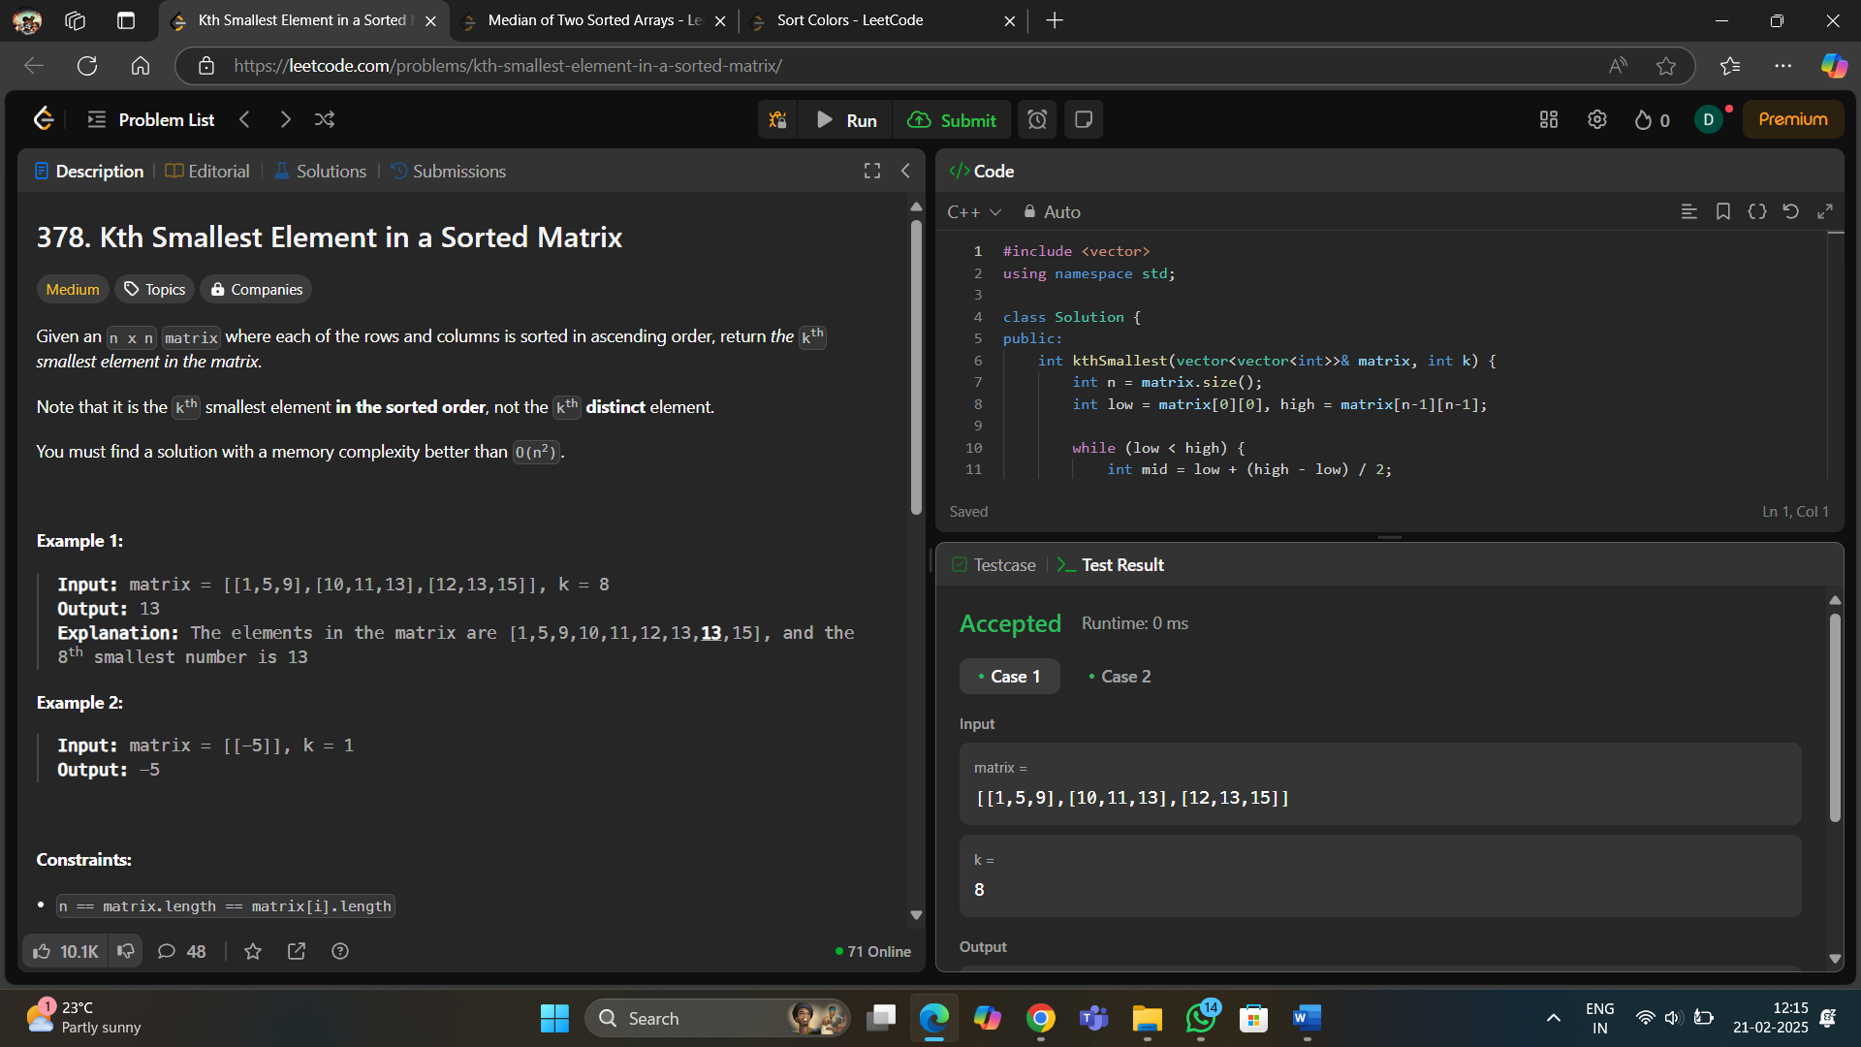**Code 5 :**
6. 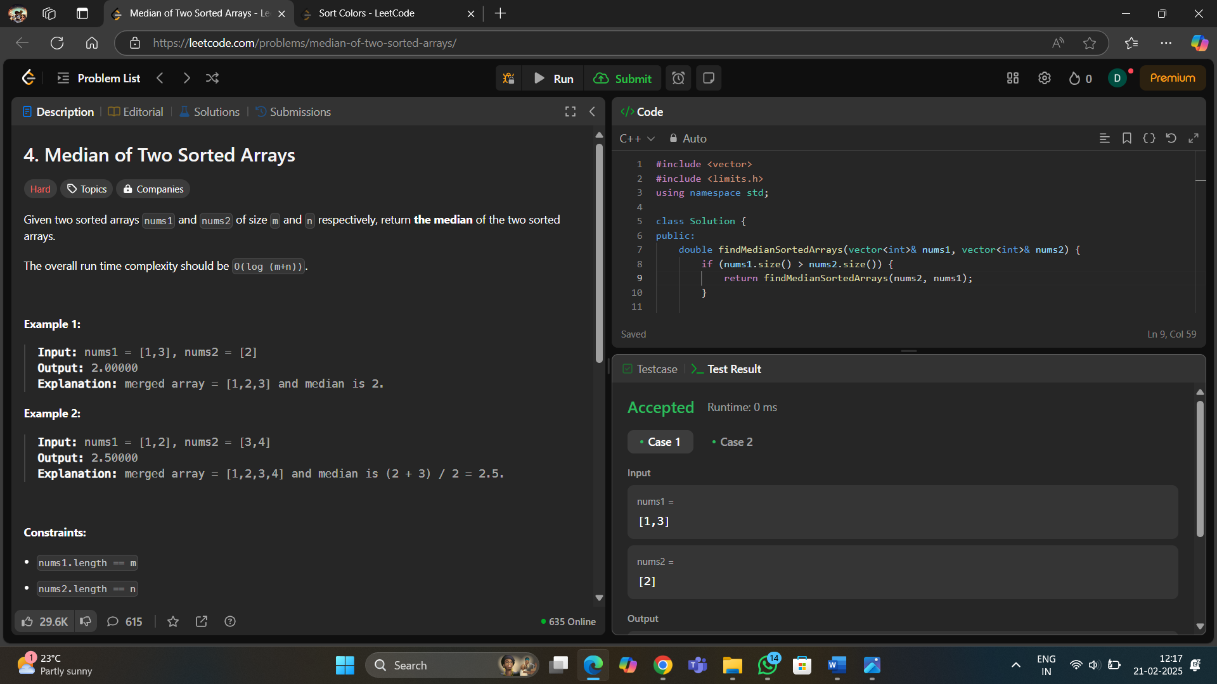**Code6 :**
7. 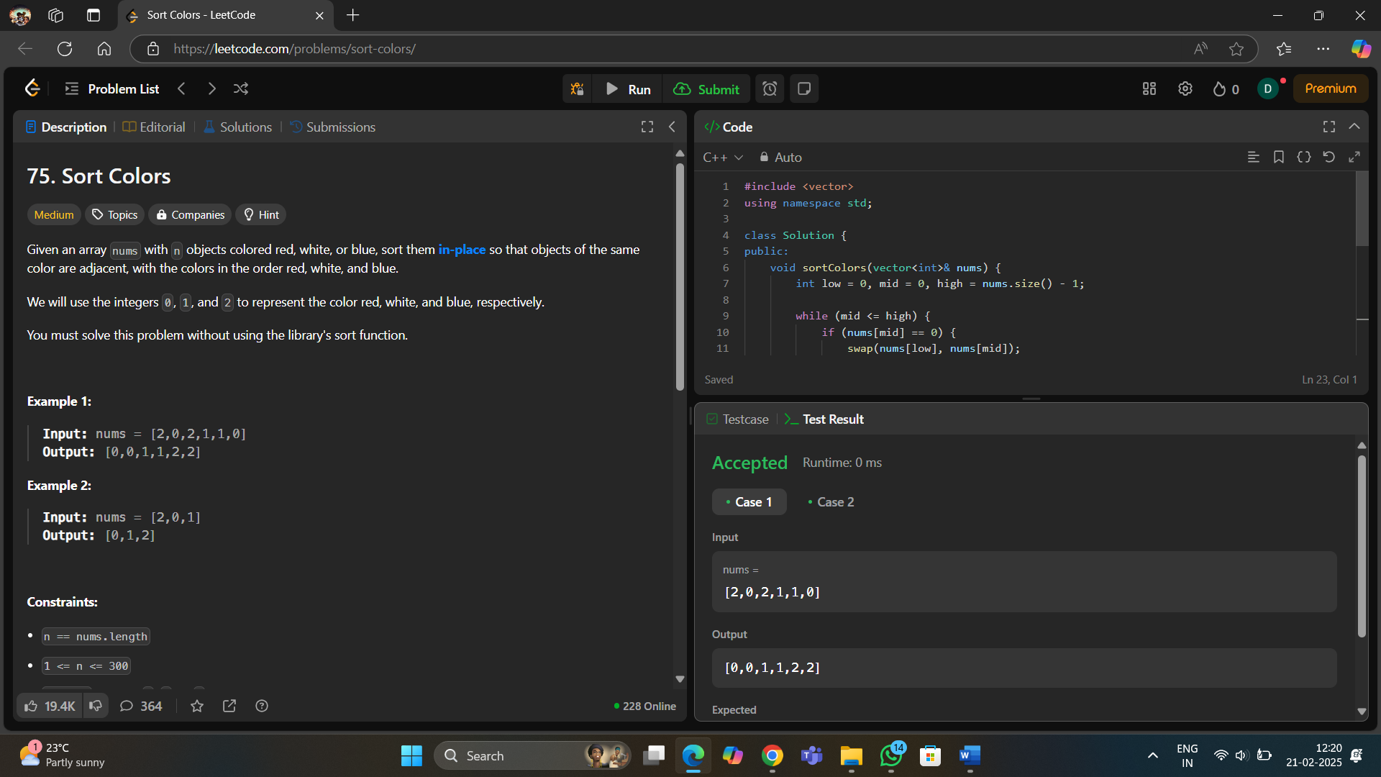**Code 7 :**
8. **Learning Outcome:**

* Using a Min-Heap (Priority Queue) to maintain the k largest elements.
* QuickSelect (Hoare’s Selection Algorithm) for finding the kth largest element in O(n) average time complexity.
* Sorting + Merging Technique to process overlapping intervals.
* inary Search in a Rotated Array.
* Matrix traversal from the top-right or bottom-left for O(m + n) complexity.
* Using a Min-Heap to extract the smallest k elements efficiently.
* Optimal O(log(min(m, n))) solution instead of naive merging (O(m+n)).
* Three-way partitioning using three pointers (low, mid, high).